Telephony Feature (optional)

Section Highlights
- Telephony Bed Status Updates to MEDITECH Overview
- ISR Router Integration Setup Steps
- Nortel Telephony Interface Setup Steps
- Avaya Telephony Interface Setup Steps
- Specific MEDITECH Dictionary/Parameter requirements for Telephony

Telephony Bed Status Updates to MEDITECH Overview
The MEDITECH Bed Management solution has a telephone feature that allows the housekeeping personnel to report the room status (cleaning in progress or cleaned) directly to the MEDITECH system from a telephone in the patient rooms or a Nursing station. The telephony feature can be setup using several methods. You can use the router option that integrates your facility’s PBX system (Nortel, Avaya, CISCO, NEC, etc.) with an ISR Cisco Router or use software that currently exists on your hospital’s Nortel or Avaya PBX system. The Nortel software is Hospitality Suite. The Avaya software is Guest Work Services (Hospitality Basic).

ISR Router Overview
This solution integrates your facility’s PBX system (Nortel, Avaya, CISCO, NEC, etc) with an ISR Router to facilitate updating the patient room status in the Meditech system from a telephone. In addition, the solution provides interactive voice prompts that will prompt the user (housekeeping personnel) for a housekeeper id, a room number (conditional, see note below), and a room status code (1-room cleaning in progress or 2-room cleaned). After the user successfully responds to all the prompts, a “Goodbye” message will be heard and the system will hang up the call. All prompts are spoken in English followed by Spanish.

This solution utilizes two separate setup configuration options for integrating your PBX system with the ISR Router: 1) an Analog card interface and/or 2) a PRI-T1 card interface.

The Analog card configuration will prompt the user to enter a housekeeper-id, a room number, and a room status. The added value for using this configuration is that it’s the simplest and cheapest solution, as 99% of PBX systems come with a standard Analog card by default; therefore, your facility won’t incur the expense of having to purchase one. The drawback to an analog solution is the room number cannot be automatically derived from analog lines and the user will always have to enter the room number manually.

The PRI-T1 card configuration will prompt the user to enter a housekeeper-id and a room status code. However, entering the patient room number will not be required, as the PRI-T1 configuration will automatically enter it behind the scenes. To use this configuration, you may need to purchase a PRI-T1 card if your PBX does not have one. Also, with the PRI-T1 configuration, you will be required to setup two different access numbers for your housekeeping personnel to dial when updating the room status. One of the access numbers (i.e., “3333”) will be used when dialing from a patient room to update the room status and will enable the room number to be automatically entered. The other access number (i.e., “4444”) will be used when dialing from a Nursing Station to update the room status; it will suppress the automatic passing of the room number and will prompt the user to enter it manually. Rooms that have multiple beds – but only one phone – may also require the user to enter the room number manually.

Data Flow Diagram
(PRI or Analog connection)

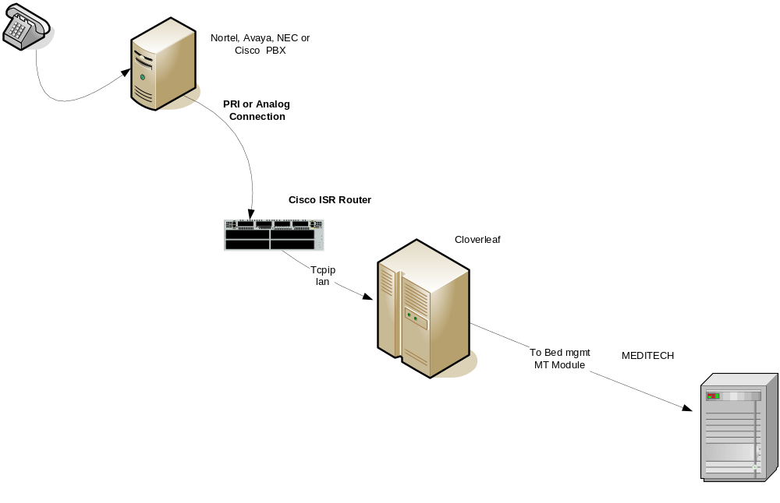

Operation – End User perspective
Call Flow:
- The Housekeeping personnel enters the patient room (or Nursing Station) and dials a predefined number to access the telephony interface. The call is routed by the PBX to a router, which launches 2 – 3 voice prompt scripts, depending on the configuration setup chosen for your facility.
- The first voice prompt says “Please enter Housekeeper ID.” The Housekeeping personnel enter their 4-digit housekeeper id.
- Conditionally (if analog configuration was employed), the second voice prompt says “Please enter the room number.” The Housekeeping personnel enter the room number, which corresponds to the 4-digit extension of the patient room phone.
- The third voice prompt says “Please enter room status”. The Housekeeping personnel will either enter a “1” (room cleaning in progress) or a “2” (room cleaned).
- The housekeeper ID, room number, room Status will be transmitted to Cloverleaf.
- The Housekeeping personnel will hear the final “Goodbye” voice prompt, and the system will hang up the call.
- Cloverleaf formats the housekeeper ID, room number, room status in an HL7 message and sends it to Meditech.

Hardware/Software Components Required:
- Cisco ISR Router (Model 2811 and 3845 are HCA standard, but any ISR will work.)
  - Standard HCA software image (Includes voice package)
  - DSP resources (PVDM) (HCA orders include PVDMs)
  - An Analog card (VWIC-2FXO or VWIC 4FXO) or PRI Card (MFT1-1T1 or MFT1 -2T1) card is used to connect the ISR Cisco router to the legacy PBX. If analog trunks are used to connect the router to the legacy PBX, H.323 or SIP trunking over Ethernet is supported and preferred by Cisco PBX.

- PRI/T1 Card with “D” channel available (optional if your desire is to have the room number to be automatically entered by your PBX and not manually entered by the Housekeeping personnel)

- CUBM Files loaded on router flash:
  - cubm.tcl – The code to run the CUBM program.
  - cubm-eem.tcl – Cisco IOS Router Embedded Event Manager policy for CUBM.
  - en_get_maid_id.au – Prompt file asking for housekeeper id.
  - en_get_room_num.au – Prompt file asking for room number.
  - en_get_status.au – Prompt file asking for room cleaning status.
  - en_goodbye.au – Prompt file to let user know program is done.

Prerequisites:
Ensure that the following dictionaries have been setup (as defined in the Bed Management System Administrators Guide) so that the telephony interface can process room status messages:
- MIS User Dictionary – Housekeepers are set up with MEDITECH access.

- ADM Customer Defined Parameters – A unique ID is setup for each housekeeper to use when reporting the bed status via the telephony interface.

- MIS Room Dictionary – This links the telephone room extension to MEDITECH room location. Extensions for each patient room that will have the status (clean or in progress) updated via the telephony interface will need to be added.

- ADM Bed Status Dictionary – Set up valid bed status codes: 1-Cleaning in progress (NMI); 2-Cleaned (NMI). (See ADMIN guide for dictionary setup steps)

Ensure that you have submitted the telephony interface request to HCA corporate and received the IP Address and Port Number from the interface technician after the interface setup is complete. This IP address and Port Number is necessary to configure your Cisco Router. Also, remember to include with your interface request the area code/prefix used for the patient phones at your facility. For example, for patient phone number 615-123-4567, the area code is “615” and the prefix is “123”.
If you do not have an onsite certified PBX technician, contact your PBX vendor and schedule an appointment for the vendor to come onsite to configure your PBX system as defined in PBX Changes Needed section.

PBX Changes Needed:

For the Analog configuration, your PBX engineer will have to assign 1 dedicated unique access number that will be used to access the telephony phone system. Since the Analog configuration requires the Housekeeping personnel to enter the room number, this same access number may be used when accessing the telephony phone system from a Nursing Station. Each Analog trunk line allows one call at a time – multiple analog trunk lines will allow multiple simultaneous calls. The pilot number should be programmed to hit a hunt group of numbers that will round-robin dial into the various analog trunks.

For the PRI-T1 configuration, your PBX engineer will have to assign 2 dedicated unique access numbers that will be used to access the telephony phone system. One number will be used when dialling from the patient room phone. The other number will be used for any situation where the user needs to manually enter the room/bed number, for example, two beds in a room with one phone.

These numbers should not be DID’s (Direct Inward Dial numbers that can be dialed from outside the facility) for security reasons.

Your PBX engineer will need to configure the PBX for the analog and/or PRI trunks connecting to the Cisco router. The engineer will also need to provision your one/two access numbers on the PBX to route calls out the trunks to the Cisco router. Documentation is included later in this document to help guide the engineer in this provisioning process.

Setup Steps for the Analog Interface Configuration:

Load the TCL scripts and audio files onto your router flash as follows:
- The router files needed are posted on the Bed Management Atlas site.
- Set up a tFTP server on your laptop
- From the router’s privileged prompt, load the following files by using the “Copy tftp: flash:” command:

  - cubm.tcl
  - cubm-eem.tcl
  - en_get_maid_id.au
  - en_get_room_num.au
  - en_get_status.au
  - en_goodbye.au

Reload the router or load cubm application
- “call application voice load cubm” from the router’d privileged command prompt will reload the cubm.tcl file from the flash into memory. Resetting the router will do the same thing, but will take longer. Watch for errors on the router console as the cubm program loads. There shouldn’t be any.

Make the site-specific changes to the Router Config file by creating an application instance to point to the Cloverleaf IP Address/Port Number for your facility:

(Note: The changes highlighted in RED are unique per facility. Only the router config file needs facility changes – the rest of the files can be left alone.)

Application service cubm flash:cubm.tcl
paramspace english index 0
param aa-pilot 234 ! Phone number dialed auto room# entry
param aa-piloT1 235 ! Phone number dialed manual room# entry
param cloverleaf-port 10846 ! Cloverleaf port for this facility
param cloverleaf-ip 170.150.226.10 ! Cloverleaf IP for this facility
param room-num-pattern ....
param maid-id-pattern ....

! OPTIONAL MONITORING
monitor
interface stats
interface event-log
stats
event-log

Add Analog trunks (Avaya/Nortel/NEC) to Router Config file:

Note: If you have analog FXO ports, PLAR the port to cubm’s pilot number.

!
voice-port 0/1/0 ! Where 0/1/0 is an FXO port on the router.
call connect 23. ! Where 23. is the number you dial for CUBM
!
!
dial-peer voice 4010 pots service cubm
incoming called-number 23. ! Run CUBM if call to 23 comes in on port
port 0/1/0
!
!

Enable the Embedded Event Manager service

scheduler allocate 20000 1000
event manager directory user policy "flash:/"
event manager policy cubm-eem.tcl

- Test the setup by following the steps outlined in the “Operation – End User Perspective” section above.

Setup Steps for The PRI-T1 Interface Configuration:

Load the TCL scripts and audio files onto your router flash as follows:
- Contact Faye Walker (Corp Prod Development) at 615-344-1476 to obtain the router files needed.
- Set up a tFTP server on your laptop
- From the router’s privileged prompt, load the following files by using the “Copy tftp: flash:” command:

  - cubm.tcl
  - cubm-eem.tcl
  - en_get_maid_id.au
  - en_get_room_num.au
  - en_get_status.au
  - en_goodbye.au

Reload the router or load cubm application
- “call application voice load cubm” from the router’d privileged command prompt will reload the cubm.tcl file from the flash into memory. Resetting the router will do the same thing, but will take longer. Watch for errors on the router console as the cubm program loads. There shouldn’t be any.

Make the site-specific changes to the Router Config file by creating an application instance to point to the Cloverleaf IP Address/Port Number for your facility:

(Note: The changes highlighted in RED are unique per facility. Only the router config file needs facility changes – the rest of the files can be left alone.)

Application service cubm flash:cubm.tcl
paramspace english index 0
param aa-pilot 234 ! Phone number dialed auto room# entry
param aa-piloT1 235 ! Phone number dialed manual room# entry
param cloverleaf-port 10846 ! Cloverleaf port for this facility
param cloverleaf-ip 170.150.226.10 ! Cloverleaf IP for this facility
param room-num-pattern ....
param maid-id-pattern ....
! OPTIONAL MONITORING
monitor
interface stats
interface event-log
stats
event-log

Add the dial peers to the Router Config file to receive calls and direct them to the CUBM TCL script application:

For IP Phones running on the same router

dial-peer voice 3001 voip
service cubm
incoming called-number *....
dtmf-relay h245-alphanumeric
codec g711ulaw
no vad

Note: If you happen to be using the same router for cubm and Call Manager Express, you must do a little trick to allow local IP phones to dial cubm’s pilot number because normally only inbound calls are accepted and a local IP phone would be dialing “outbound” to get to the cubm pilot number. So, create a Loopback interface. Send calls destined for the cubm pilot to the Loopback interface. When the call hits the loopback, it will be picked up by cubm as an “incoming” call.

interface Loopback0
ip address 100.100.100.1 255.255.255.0

dial-peer voice 3000 voip
destination-pattern 23.
session target ipv4:100.100.100.1
dtmf-relay h245-alphanumeric
codec g711ulaw
no vad

- Add the router config file parameter changes for the PRI-T1 trunk:

================================================================

Note: These are the PRI T1 Trunk parameter changes if you have a Nortel PBX.
================================================================
!
controller T1 0/0/0
cablelength short 133 ! Use short command if router is next to PBX.
pri-group timeslots 1-24
description TONORTEL
!
!
interface Serial0/0/0:23
description TONORTEL
no ip address
encapsulation hdlc
isdn switch-type primary-dms100 ! Emulate Nortel DMS100 (Q.SIG/NI/NI2..many options)
isdn protocol-emulate network ! Cisco D-Channel is network side
isdn incoming-voice voice
isdn channel-id invert extend-bit
no cdp enable
!
!
dial-peer voice 4000 pots service cubm
incoming called-number 23. ! Run CUBM if call to 23. comes in on PRI
direct-inward-dial
port 0/0/0:23
!

=================================================================
Note: These are the PRI T1 Trunk parameter changes if you have an AVAYA PBX.
=================================================================

PRI E1 (Could be T1 as well) Trunk from Avaya
!
controller E1 1/0 ! This example is PRI E1 instead of T1
framing NO-CRC4
pri-group timeslots 1-31
description ECN-4
!
interface Serial1/0:15
description D-channel for ECN-4
no ip address
no logging
event link-status
isdn switch-type primary-net5
isdn overlap-receiving
isdn incoming-voice voice
isdn send-alerting
isdn bchan-number-order ascending
isdn sending-complete
isdn outgoing display-ie
no cdp enable
!
!
dial-peer voice 4000 pots service cubm
incoming called-number 23. ! Run CUBM if call to number 23. direct-inward-dial
port 1/0:15
!

Enable the Embedded Event Manager service

scheduler allocate 20000 1000
event manager directory user policy "flash:/"
event manager policy cubm-eem.tcl

- Test the setup by following the steps outlined in the “Operation – End User Perspective” section above.

Create Connection from Cisco CUCM (PBX) to cubm router

Cisco PBXs can communicate directly from the PBX to the router over the HCA corporate LAN/WAN. No PRI or analog ports needed.

On the CUCM (Cisco Unified Communications Manager) side, use the web based administration to add a “Device/Gateway/H.323 Gateway” using the IP address of the router as the H.323 Gateway name.
Then add a Call Routing/Route Plan/Dial Pattern so the phones on CUCM will be able to dial the CUBM application. i.e. “*1234” Have the route pattern point to the H.323 Gateway defined above.

On the CUBM router, put the following in the router’s config so it can receive calls from CUCM:

!Create Dial Peer to receive calls and direct them to the cubm application
dial-peer voice 3001 voip
service cubm
incoming called-number *....
dtmf-relay h245-alphanumeric
codec g711ulaw
no vad

Troubleshooting
- CUBM script does not answer when dialed:
  - PBX isn’t routing the call correctly.
  - Connection from PBX to PRI is broken.

- CUBM script plays garbled sounding prompts:
  - Router is overloaded with other tasks
  - Prompt file is incorrect format

- Meditech/Cloverleaf is not receiving any information from CUBM script
  - Check network connectivity from router to Cloverleaf
  - Check Cloverleaf connection to Meditech

- Provide debug details for the next call into CUBM script
  - monitor call application event-log app-tag cubm next

- Debug the cubm script application as it runs – view diag info on terminal screen
  - From the router command prompt: Debug voip ivr script
  - Other options for debug voip ivr options: [states | error | tclcommands | callsetup | digitcollect | script | dynamic | applib | settlement | all]

- To debug the Embeded Event Manager
  - debug event manager action cli

- Reload cubm application after making changes
  - “call application voice load cubm” from the router’s privileged command prompt will reload the cubm.tcl file from the flash into memory. Resetting the router will do the same thing, but will take longer. Watch for errors on the router console as the cubm program loads. There shouldn’t be any.

Caveats/Warnings
- The data passes “In the clear” over the network.
- There aren’t many authentication controls – would be possible to “spoof” cubm over the network and create a denial-of-service attack against bed management. (Un-likely)

Nortel Overview
HCA has approximately a 70 percent install base of Nortel PBX phone system. Most of the installations are at a code level that offers Nortel’s Hospitality Suite. This enables the use of the hospital’s phone to be an input device for reporting patient room status. To maximize our current Nortel PBX system and hospitality application, a Lantronix box will be used to convert the PBX output from serial to IP. Bed status messages will be reformatted by the Cloverleaf engine to HL7 format.
This interface is written to accommodate Nortel messages (as formatted by Cloverleaf) and other bed management that are compliant with HL7 version 2.4.
This interface supports the transmission of an A20 event.

Nortel Telephony Interface Network Diagram

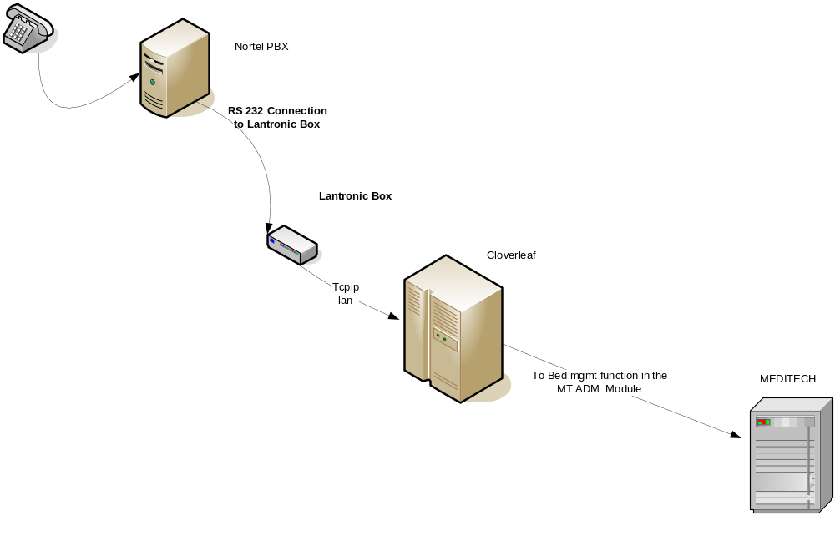

Nortel Telephony Interface Setup Steps

To setup your telephony interface with the Nortel PBX system, complete the following steps in order:

- Ensure that the following dictionaries have been setup (as defined in the System Administrators Guide) so that the telephony interface can process room status messages:
- MIS User Dictionary – Housekeepers must be set up with MEDITECH access.

- ADM Customer Defined Parameters – Setup unique ID that each housekeeper will use when reporting the bed status via the telephony interface.

- MIS Room Dictionary – Links telephone extension to MEDITECH room location. You must setup an entry in this dictionary for each patient room that will have the status (clean or in progress) updated via the telephony interface.

- ADM Bed Status Dictionary – Set up valid bed status codes: 1-Cleaning in progress (NMI); 2-Clean (NMI). (See ADMIN guide for dictionary setup steps)

- Ensure that your Nortel PBX system meets the requirements listed in the Nortel Software Requirements section below.
- Ensure that you have purchased the hardware listed in the Nortel Hardware Requirements section below.
- Ensure that you have submitted the telephony interface request to HCA corporate and received the IP Address and Port Number from the interface technician after the interface setup is complete. This IP address and Port Number will be needed to configure your Lantronix Box.
- If you do not have an onsite certified Nortel PBX technician, contact your Nortel PBX vendor and make arrangements for the vendor to come onsite to configure your Nortel PBX system to integrate with the Bed Management telephony feature.
- Identify/Document all patient room phones that will be used by the housekeeping staff to report the room status and then provide the phone numbers to your PBX technician. The technician will assign these specific phone numbers to the CCSA class during the Nortel PBX configuration setup process.
- Configure your Nortel PBX system according to the Configuring Nortel PBX Settings section below. After the configuration is complete, obtain the Spree code from your PBX technician. This is a facility-specific code that your housekeepers will use to update the room status from a patient room phone.
- Configure your Lantronix Box according to the Configuring Nortel Lantronix Box Settings section below.
- Connect the Nortel PBX system server to the Lantronix box by running the DB25 Serial Straight thru cable from the PBX server to the serial port on the Lantronix Box.
- Connect the Lantronix Box to Cloverleaf by running the Ethernet cable from the RJ45 port on the Lantronix box to the Cloverleaf server.
- Validate that data is passing from your PBX system to the Meditech NMI module by following the steps in the Nortel PBX – How to Update the Room Status from the Phone in the Patient Room section.

Nortel Hardware Requirements
- UDS 1100 Lantronix Box
- Six feet DB9F-to-DB25M Modem cable; the modem cable that comes with your Lantronix Box will not work with this configuration, so that’s why you’ll need to purchase this cable.
- Network Data Drop in Phone Room for Lantronix

Nortel Software Requirements

A. The Maid ID feature must be available with the Hospitality package on your Nortel PBX system. This feature is included with the succession series beginning with Release 1 and beyond. It was an optional feature on prior releases of the Nortel PBX OS.
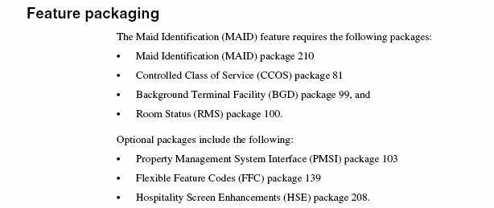

The interface has been certified with the following operating system version levels:

- Nortel Succession 4.5 and Succession 5.5

Note: Your PBX system must be utilized with only one MEDITECH facility (e.g. – all data for that PBX system will be populated with the same MEDITECH facility mnemonic). There is an available TTY port and must be a Nortel telephone associated with each bed.

Configuring Nortel PBX Settings
DISCLAIMER: Due to the risk associated with changes to the PBX settings, the instructions in the “Nortel Communication Server 1000” section are written from the perspective of a trained technician (other parties should not attempt to make these changes).

- Configure the “USER” and “CTYP” entry settings as follows:
- The PBX technician programs an SDI or MSDL port in LD 17. The USER entry must be programmed as PMS. The other entries do not need to be changed and may vary by facility.

ADAN TTY 2
CTYP (SDI2 or MSDL)
GRP 1
DNUM 2
DES pmsi
FLOW NO
USER BGD PMS. Program PMS in “User” on the TTY port used for Bed Management
CUST 00
XSM NO

2. Configure the Class of Service Settings as follows:

- The PBX technician programs the Bed Management telephone with CCSA in the class of service in LD 20. The other entries do not need to be changed and may vary by facility.

DES 31Q54B
TN 056 0 08 04
TYPE 3904
CDEN 8D
CTYP XDLC
CUST 0
FDN 1344
TGAR 8
LDN NO
NCOS 2
SGRP 0
RNPG 0
SCI 0
SSU
LNRS 16
XLST
CLS CTD FBD WTD LPR MTD FNA HTA TDD HFA GRLD CRPD STSD
MWA LMPN RMMD SMWD AAD IMD XHD IRA NID OLA VCE DRG1
POD DSX VMD CMSD SLKD CCSA-CSI (Program CCSA in the class of service on phones that will be used in Bed Management) SWD LNA CNDA
CFTD SFD MRD DDV CNID CDCA MSID DAPA BFEA RCBD
ICDD CDMD LLCN MCTD CLBD AUTU
GPUD DPUD DNDD CFXD ARHD CLTD ASCD
CPFA CPTD ABDD CFHD FICD NAID BUZZ AGRD MOAD AHD
DDGA NAMA
DRDD EXR0
USMD USRD ULAD RTDD RBDD RBHD PGND FLXD FTTU DNDY DNO3 MCBN

3. Assign the “CCSA” class of service to all the patient room phones as well as any station phones that will be used to update the room status.

Configuring Nortel Lantronix Box Settings

- Setup a Telnet or Terminal connection (connecting a PC or Terminal to the serial port on your Lantronix box) to access the setup mode of your Lantronix box so that you can configure it.

Note: See the UDS1100 User Guide that’s located on the CD packaged with your Lantronix Box for details on setting up a Telnet or Terminal connection and establishing configuration settings.

- Configure the Network Settings as follows:
- Network Mode Wired Only

- Auto Configuration Methods
BOOTP Enable
DHCP Enable
Auto IP Enable

- IP Configuration
IP Address Static IP supplied by facility IT&S
Subnet Mask: Supplied by facility IT&S
Default Gateway Supplied by facility IT&S

- Ethernet Configuration
Auto Negotiate x
Speed 100 Mbps
Duplex Full

- Configure the Server Settings as follows:

- Server Configuration
Telnet Password Blank
Retype Password Blank

- Advanced
ARP Cache Timeout (secs) 600
TCP Keepalive (secs) 45
Monitor Mode @ Bootup Enable
HTTP Server Port 80
0x77FE Server Port 30718
MTU Size 1400

- Configure the Hostlist Settings as follows:
Retry Counter 3
Retry Timeout 250

- Configure the Serial Settings as follows:

- Port Settings
These settings should match the Baud Rate, Flow Control, Parity, Stop bits on your PBX
The Data Bits has to be set at 7 for the Nortel PBX
Protocol RS232
Baud Rate 1200
Data bits 7
Flow Control None
Parity None
Stop Bits 1

- Pack Control
Idle Gap Time: 12 msec
Send Trailing Bytes None

- Flush Mode
Flush Input Flush Out
Buffer Buffer
With Active Connect No No
With Passive Connect No No
At Time of Disconnect No No

- Configure the Connection Settings as follows:
Channel 1
- Connect Protocol
Protocol TCP

- Connect Mode
Passive Connection
Accept Incoming Yes
Password Required No
Modem Escape Sequence
Pass Through Yes

Active Connection
Active Connect None
Start Character 0D
Modem Mode None
Show IP Address Yes

- Configure the Endpoint Configuration setting as follows:

- Local Port – Default setting is 10001
- Remote Port – Provided by Corporate Cloverleaf Interface (use the port that goes into NMI, not the one that goes out to Meditech)
- Remote Host – Provided by Corporate Cloverleaf Interface

- Configure the Common Options as follows:
- Telnet Com Port Disable
- Connect Response None
- Use Hot List No

- Configure the Disconnect Mode as follows:

- On Mdm_Ctrl_In No
- Check EOT No
- Hard Disconnect Yes

- Setup Connection between Nortel and Lantronix Box:
- Serial Cable with Null Modem is required. If the TTY port is set to DTE, no NULL Modem is required.

- Connection between Lantronix Box and Cloverleaf:
- IP address, ports, and& Cloverleaf parameters*. Must be set up and configured in Cloverleaf by the HCA corporate interface implementations group. Request needs to be submitted by the HDIS or his designee via the Atlas/Cloverleaf web portal. Link is attached here for reference.

Note:
- Technical support is provided by Lantronix M-F from 9:00 AM ET to 8:00 PM ET.
- Lantronix Technical Support: 800-422-7044.

Nortel Cloverleaf and Interface Considerations
- The Cloverleaf engine accepts the transmission from the Lantronix box and format in HL7 format in accordance with MEDITECH interface specification, Other Vendor Bed Status Update to MEDITECH Admissions.

- When requesting the interface connection, you’ll need to provide Cloverleaf with area code and phone exchange for your facility. For instance, if your facility’s main number is 615-344500, your area code would be “615” and your exchange is “344”.

- To properly read transmissions from the Lantronix Box, each transmission must begin with STX character and the transmission must end with ETX.

- The integration consultant assigned by HCA corporate l works with each site to finish the configuration and test the interface prior to moving it into production.

- Training should be provided to sites that do not already have a working knowledge of MEDITECH NMI and Cloverleaf. This is done remotely

Nortel PBX - How to Update the Room Status from the Phone in a Patient Room
- Lift the handset.
- Enter your facility’s unique four-digit spree code followed by “86”.
- Enter a cleaning status code:
2 = Cleaning in progress
3 = Cleaned
- Press the “*” button. This sets the display to accept the Maid ID.
- Enter the four-digit Maid ID. The digits are shown on the display, if equipped.
- Press the “#” button to end the Maid ID entry..
- Hang up the handset..

Trouble Shooting -- Nortel

You may setup a HyperTerminal session with the Host Address, Port Number, and Connect settings listed below to verify that your Lantronix Box is receiving data from the PBX switch. We recommend that you do this before verifying that data is passing from the PBX switch to NMI.

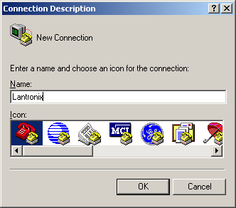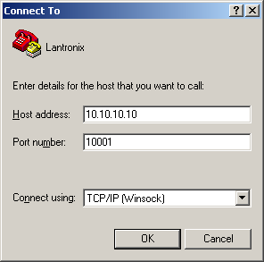
Host address: Enter the IP address of the Lantronix box. In the example, the host address is 10.10.10.10
Port number: Enter the local port of the Lantronix Box – default is 10001

This is the screen that you will be able to see the data from the Phone System.
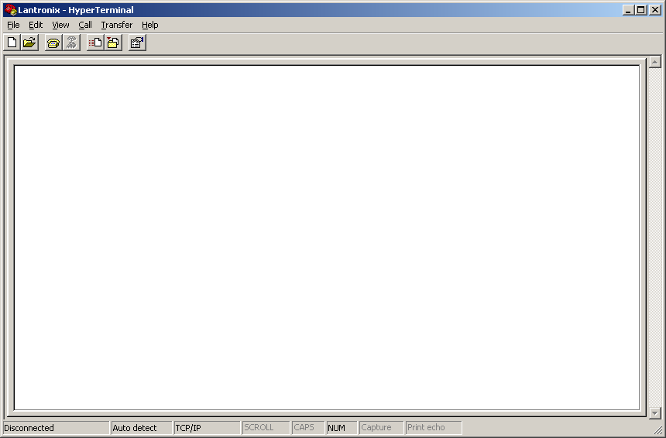

Nortel Sample NMI Messages

The following screens are sample NMI interface messages you will see when you update the phone status and the data is passed from the Nortel PBX switch to Meditech:

- Example of Interface Message from NMI into MEDITECH when user updates room status with a cleaning code of “1” (cleaning In Progress):

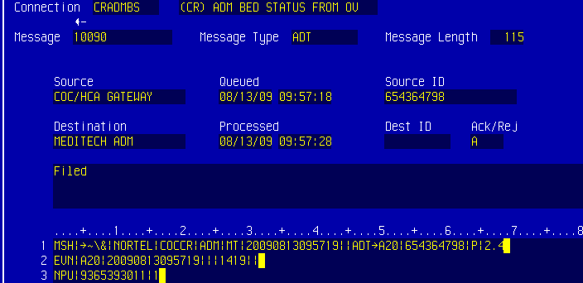
1 MSH|^~\&|NORTEL|COCCR|ADM|MT|2009080130957||ADT^A20|654364798|P|2.4
Line 1: Is the type of Interface(NORTEL), Facility(COCCR), Date/Time

2 EVN|A20|20090813095719|||1419||
Line 2: Date/Time and the Housekeeper ID (9999)

3 NPU|9365393011|1
Line 3: Housekeeping Room Extension (9365393011) and Room Status Code (1 – In Progress(NMI))

- Example of Interface Message from NMI into MEDITECH when user updates room status with a cleaning code of “2” (room clean):

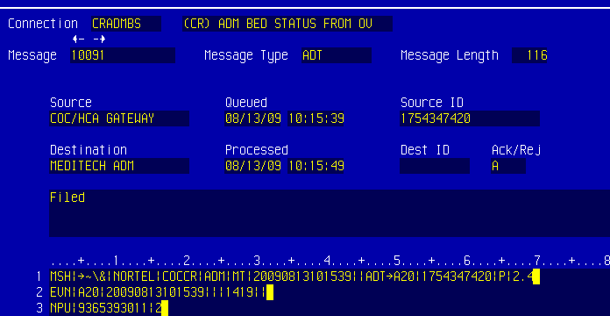
1 MSH|^~\&|NORTEL|COCCR|ADM|MT|20090813101539||ADT^A20|754347420|P|2.4
Line 1: Is the type of Interface(NORTEL), Facility(COCCR), Date/Time
2 EVN|A20|20090813101539|||1419||
Line 2: Date/Time and the Housekeeper ID (1419)

3 NPU|9365393930|2
Line 3: Housekeeping Room Extension (9365393930) and Room Status Code (2 – Clean (NMI))

- Example of Rejection of Data from Phone Switch thru NMI to MEDITECH.

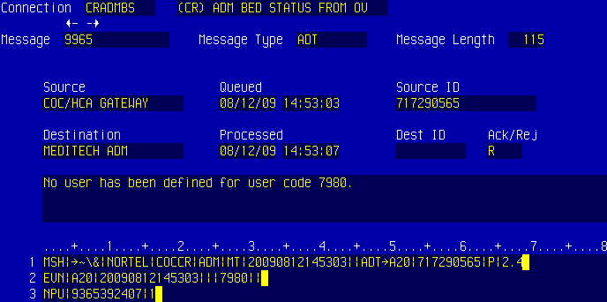
No user has been defined for user code 7980.
This error means that no Housekeeper has been setup with this code on Page 3 of the ADM Customer Defined Parameters.
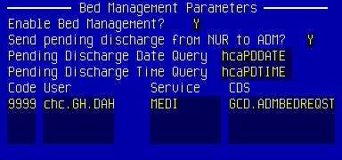

- Example of Rejection of Data from Phone Switch thru NMI to MEDITECH.

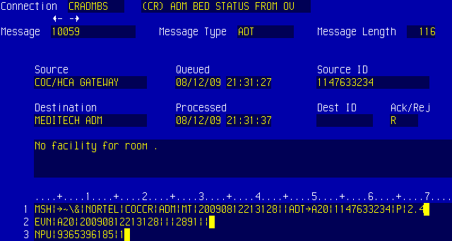
No facility for room.
This error means that the Housekeeping Extension (9365396185) is not setup in the room dictionary.
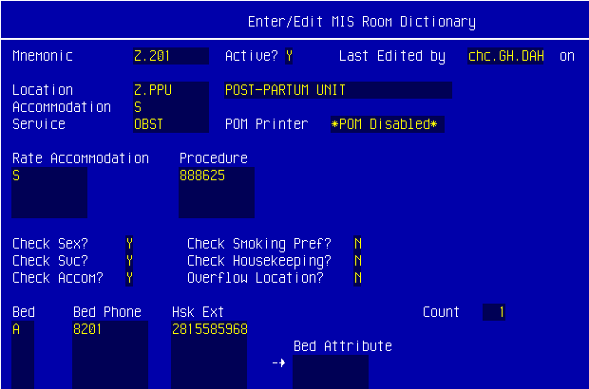

Avaya Overview
HCA has approximately 10 – 20 percent install base of the Avaya PBX phone system. Most of the installations have a code level that offers the Guest Work Services (Hospitality Basic) feature. This feature enables the hospital’s phone to be an input device for reporting the room’s bed status. To maximize current Avaya PBX system and hospitality application, a Lantronix box is used to convert the PBX output from serial to IP. Bed status messages are reformatted by Cloverleaf engine to HL7 format. Other hardware needed is defined below.
Interface was written to accommodate Avaya messages (as formatted by Cloverleaf) and other bed management that are compliant with HL7 version 2.4.
This interface supports the transmission of an A20 event.

Avaya Telephony Interface Network Diagram
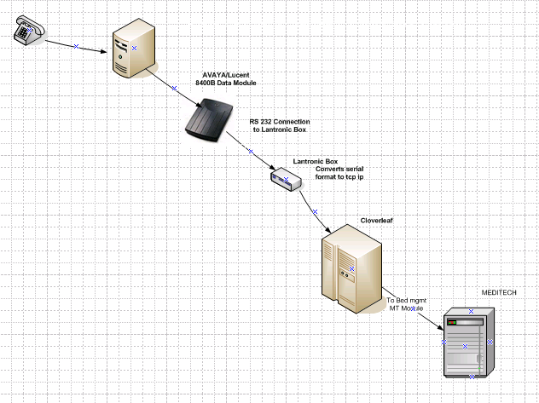

Avaya Telephony Interface Setup Steps

To setup your telephony interface with the Avaya PBX system, complete the following steps in order:

- Ensure that the following dictionaries have been setup (as defined in the System Administrators Guide) so that the telephony interface can process room status messages:
- MIS User Dictionary – Housekeepers must be set up with MEDITECH access.

- ADM Customer Defined Parameters – Setup unique ID that each housekeeper will use when reporting the bed status via the telephony interface.

- MIS Room Dictionary – Links telephone extension to MEDITECH room location. You must setup an entry in this dictionary for each patient room that will have the status (clean or in progress) updated via the telephony interface.

- ADM Bed Status Dictionary – Set up valid bed status codes: 1-Cleaning in progress (NMI); 2-Clean (NMI).

- Ensure that your Avaya PBX system meets the requirements listed in the Avaya Software Requirements section below.
- Ensure that you have purchased the hardware listed in the Avaya Hardware Requirements section below.
- Ensure that you have submitted the telephony interface request to HCA corporate and received the IP Address and Port Number from the interface technician after the interface setup is complete. This IP address and Port Number will be needed to configure your Lantronix Box.
- If you do not have an onsite certified Avaya PBX technician, contact your Avaya PBX vendor and make arrangements for the vendor to come onsite to configure the Hospitality Basic feature of your Avaya PBX system to integrate with the Bed Management telephony feature.
- Configure your Avaya PBX system according to the Configuring Avaya PBX Settings section below. After the configuration is complete, obtain the Spree code from your PBX technician. This is a facility-specific code that your housekeepers will use to update the room status from a patient room phone.
- Configure your Lantronix Box according to the Configuring Avaya Lantronix Box Settings section below.
- Connect the Avaya PBX switch to the Lucent 8400 Data Module using a serial cable.
- Connect the Data Module to the Lantronix box by running the DB25 Serial Straight thru cable from the PBX server to the serial port on the Lantronix Box.
- Connect the Lantronix Box to Cloverleaf by running the Ethernet cable from the RJ45 port on the Lantronix box to the Cloverleaf server.
- Validate that data is passing from your PBX system to the Meditech NMI module by following the steps in the Avaya PBX – How to Update the Room Status from the Phone in the Patient Room section.

Avaya Hardware Requirements
- Avaya/Lucent 8400B Data Module
- 1 Digital Phone Line for Data Module
- UDS 1100 Lantronix Box
- Network Data Drop in Phone Room for Lantronix
- DB9m to DB25m Serial Straight Thru Cable
- DB25 Null Modem Adapter (needed to connect Data module to Lantronix Box) can be purchased at any local Computer supply store.
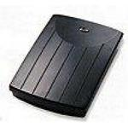Avaya/Lucent 8400B Data Module
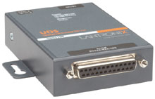UDS 1100 Lantronix Box
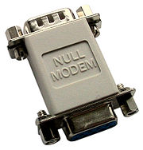DB25 Null Modem Adapter

Avaya Software Requirements

- The Avaya Hospitality Basic feature must be active in the switch.

Configuring Avaya PBX Settings

- Configure the Hospitality (Basic) parameter by setting it to “Y” (Yes) as indicated in the screen shot below.

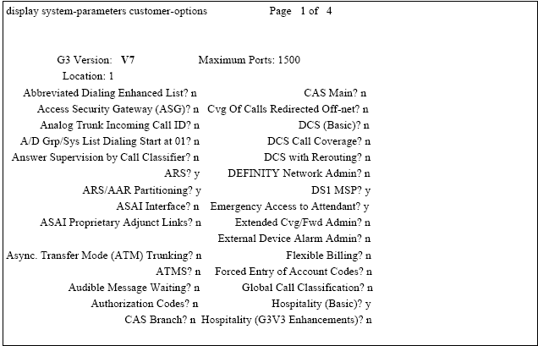

2) Identify the patient room phones and then configure the Class of Service by setting the Client Room parameter to “Y”. See sample screen below.
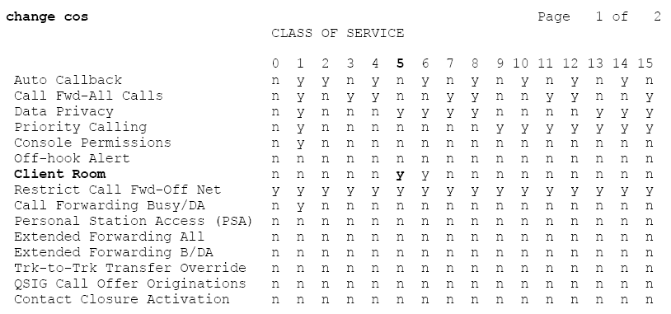

- Go to page 5 of the Feature Access Codes screen, and configure the access codes as indicated in the screen shot below. Note: These are facility specific in reference to the Dialing Plan on the phone switch.

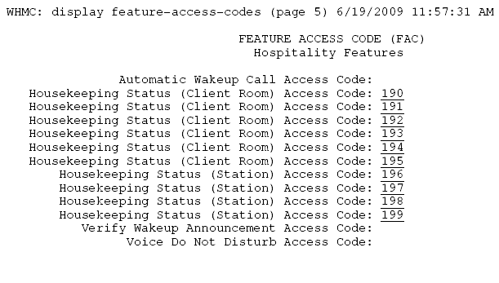

Below is the list of the access codes that will be used for the Bed Management telephony feature along with a description of the codes:

When the Room Status code 191 is entered from a patient room phone, the telephony interface will pass a CODE 2 (In Progress) to NMI.

When the Room Status code 192 is entered from a patient room phone, the telephony interface will pass a CODE 3 (Clean) to NMI.

When the Room Status code 197 is entered from a Station phone, the telephony interface will pass a CODE 2 (In Progress) to NMI.

When the Room Status code 198 is entered from a Station phone, the telephony interface will pass a CODE 3 (In Progress) to NMI.

Screen shot of the Dial Plan Analysis Table

If you look at the Dialed String 19 it has a total length of 3 and Call Type of FAC (Feature access code).

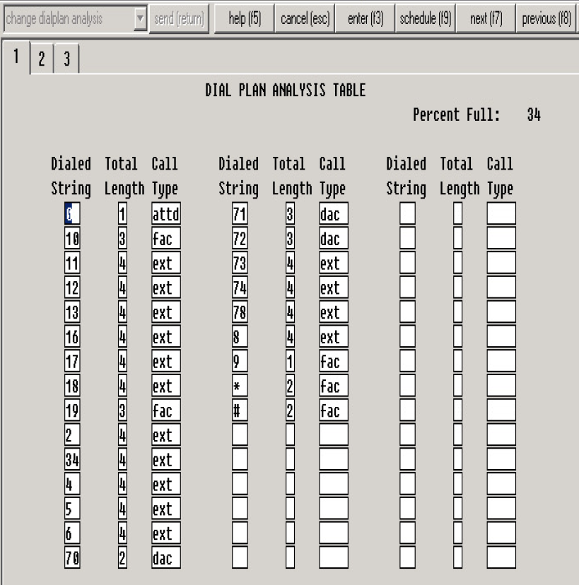

- Set the PMS Log Endpoint to the extension that is assigned to the Data Module. In the screen example below, the PMS Log Endpoint is 5910. Ensure that all other settings are setup as indicated on the screen shot below.

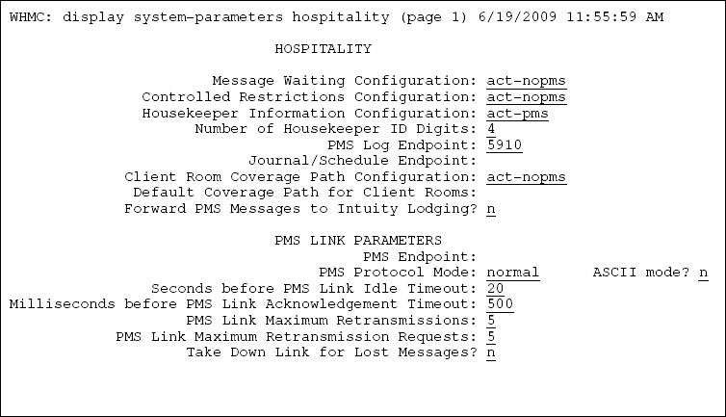
Configure the “Automatic Selection of DID Numbers” and “Number of Digits Parameters” as indicated below. See screen example below.
Automatic Selection of DID Numbers? Y
Number of Digits from PMS: 4
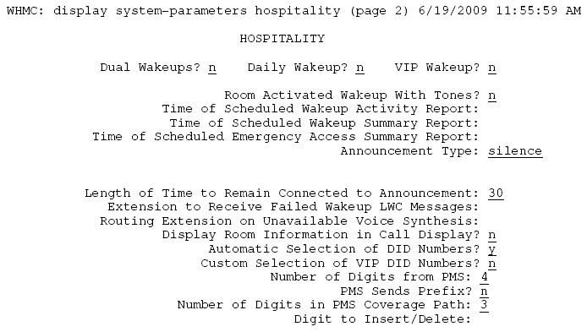

- Configure the “Room State” parameters as indicated in screen below:
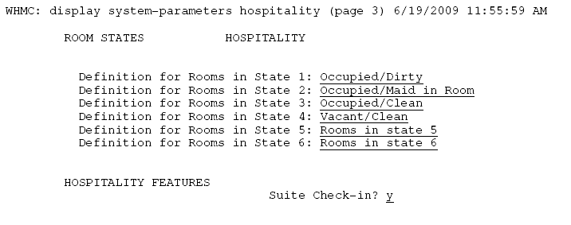
Note: These are the 2 Codes that get sent over to NMI to update MEDITECH:
- 2: Occupied/Maid in Room ** (Cleaning is in progress)
You can enter any description in this field, this is what the vendor had setup in the switch for this facility.

- 3: Occupied/Clean ** (Room is clean)
You can enter any description in this field, this is what the vendor had setup in the switch for this facility.
Note: The descriptions do not matter. The telephony interface only utilizes room state codes “2” and “3”, not the descriptions.

Configuring Avaya Data Module Settings
- To access the setup mode to configure the Data Module, you must connect an Ascii Data Terminal or PC (with terminal emulation) to the Serial Port on the back of the Data Module. Only a subset of options must be changed. These options are changed using the AT command set.
Note: The distance limit when connecting a data module to a TN2214 or TN2224 with 24awg wire is 3500 feet.

- Configure the Data Module settings as outlined below:

  - Data extension assigned is facility specific
  - Type: pdm
  - Port: Digital Port that the extension is connected to
  - Name: This is facility specific
  - COS: Facility Specific
  - COR: Facility Specific assigned to Data Modules
  - Ensure that the remaining settings are configured as outlined in the screen shot of the digital port below:
Example: 01D1910 – Digital Port Screen Shot
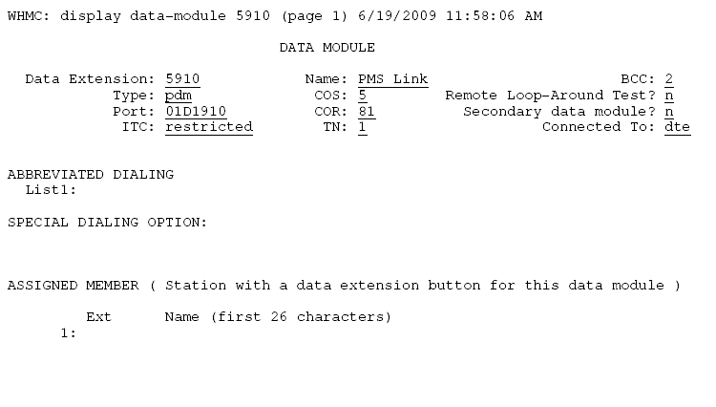
- Use the following steps to set the options on the Data Module:

- Set the speed on the data terminal or terminal emulation package to match the speed set in the Lantronix Box (9600 is the default). By doing this, the speed on the 8400B will autobaud to match the correct speed. See screen sample below.
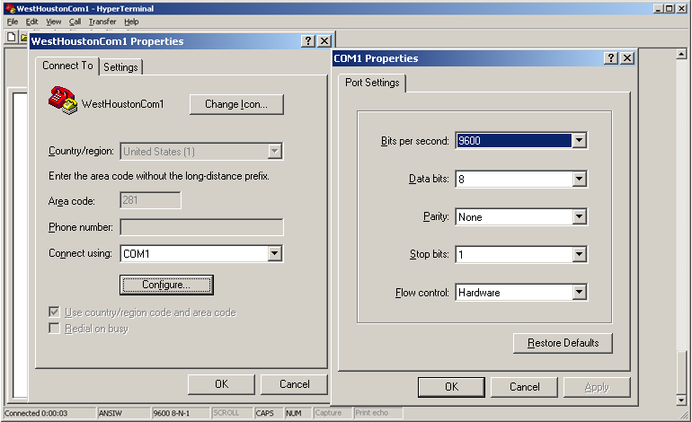

- From the data terminal or PC, type AT then ENTER. This automatically sets the speed and parity for the connection. The OK prompt should display.
- Type the following commands as shown. (The character 0 is the number zero.) Before you press ENTER for each command, make sure that the command had been entered correctly. The e0 option on the last command turns off keyboard echo, which means that after you enter this command any future keyboard entries will not be displayed, and the OK prompt is not displayed.
  - At&f then ENTER Key (the OK prompt displays)
  - Ats24=1 then ENTER Key (the OK prompt displays)
  - At&c1&d2&s1s0=1 then ENTER Key (the OK prompt displays)
  - Ate0q1&w0&y0&v then ENTER Key
  - The &v portion of the last command displays the current set of options. Your screen should look something like this:
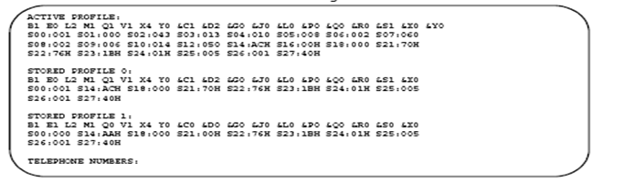
- Disconnect the data terminal or PC from the 8400B.
- Reconnect the unit to the Lantronix Box after you configure the Lantronix Box.
- Cycle power on the 8400B (disconnect the line cord momentarily)
- Connect the Lantronix Box.
Note: Once you have setup the 8400B data module, connect the Lantronix Box to the Serial Port using a DB9 to DB 25 cable with a NULL Modem Adapter.

Configuring Avaya Lantronix Box Settings

- Setup a Telnet or Terminal connection (connecting a PC or Terminal to the serial port on your Lantronix box) to access the setup mode of your Lantronix box so that you can configure it.

Note: See the UDS1100 User Guide that’s located on the CD packaged with your Lantronix Box for details on setting up a Telnet or Terminal connection and establishing configuration settings.

- Configure the Network Settings as follows:
- Network Mode Wired Only

- Auto Configuration Methods
BOOTP Enable
DHCP Enable
Auto IP Enable

- IP Configuration
IP Address Static IP Supplied by facility IT&S
Subnet Mask: Supplied by facility IT&S
Default Gateway Supplied by facility IT&S

- Ethernet Configuration
Auto Negotiate x
Speed 100 Mbps
Duplex Full

- Configure the Server Settings as follows:

- Server Configuration
Telnet Password Blank
Retype Password Blank

- Advanced
ARP Cache Timeout (secs) 600
TCP Keepalive (secs) 45
Monitor Mode @ Bootup Enable
HTTP Server Port 80
0x77FE Server Port 30718
MTU Size 1400

- Configure the Hostlist Settings as follows:
Retry Counter 3
Retry Timeout 250

- Configure the Serial Settings as follows:
- Port Settings
These settings should match the Baud Rate, Flow Control, Parity, Stop bits on your PBX
The Data Bits has to be set at 7 for the Nortel PBX
Protocol RS232
Baud Rate 1200
Data bits 7
Flow Control None
Parity None
Stop Bits 1
- Pack Control
Idle Gap Time: 12 msec
Send Trailing Bytes None
- Flush Mode
Flush Input Flush Out
Buffer Buffer
With Active Connect No No
With Passive Connect No No
At Time of Disconnect No No

- Configure the Connection Settings as follows:

Channel 1
- Connect Protocol
Protocol TCP
- Connect Mode
Passive Connection
Accept Incoming Yes
Password Required No
Modem Escape Sequence
Pass Through Yes
Active Connection
Active Connect None
Start Character 0D
Modem Mode None
Show IP Address Yes

- Configure the Endpoint Configuration setting as follows:

- Local Port – Default setting is 10001
- Remote Port – Provided by Corporate Cloverleaf Interface (use the port that goes into NMI, not the one that goes out to Meditech)
- Remote Host – Provided by Corporate Cloverleaf Interface

- Configure the Common Options as follows:
- Telnet Com Port Disable
- Connect Response None
- Use Hot List No

- Configure the Disconnect Mode as follows:

- On Mdm_Ctrl_In No
- Check EOT No
- Hard Disconnect Yes

Avaya PBX: Housekeeper Steps to Change Room Status from the Phone in the Patient Room

- Pickup the Patient Phone
- Enter a cleaning status code:
  - 191 = Cleaning In Progress (housekeeping is in room and cleaning is in progress)
  - 192 = Cleaned (housekeeping has finished cleaning the room)
- Enter your maid ID (XXXX); after confirmation tone, hang up the phone.

Avaya PBX: Housekeeper Steps to Change Room Status from the Station Phone.

- Pick up the Nurses station Phone
- Enter the Room Phone Extension (not room number) of the Room for which you’re updating the room status.
- Enter a cleaning status code:
197 = Cleaning In Progress (housekeeping is in room and cleaning is in progress)
198 = Cleaned (housekeeping has finished cleaning the room)
- Enter your maid ID (xxxx); after confirmation tone, hang up the phone.

Avaya Housekeeping Staff Quick Reference Cards
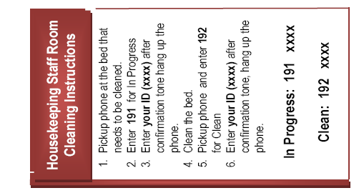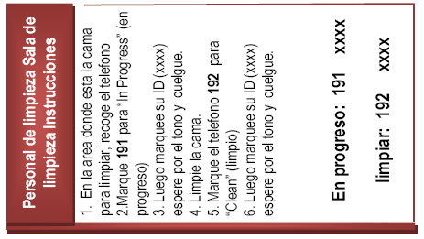

Trouble Shooting -- Avaya
You may setup a HyperTerminal session with the Host Address, Port Number, and Connect settings listed below to verify that your Lantronix Box is receiving data from the PBX switch. We recommend that you do this before verifying that data is passing from the PBX switch to NMI.

Host address: Enter the IP address of the Lantronix box. In the example, the host address is 10.10.10.10
Port number: Enter the local port of the Lantronix Box – default is 10001

This is the screen that you will be able to see the data from the Phone System.

- When data is not crossing over to the Lantronix box and you reset the Data Module, you will have to toggle the Data Module, change system-parameters hospitality in the Avaya Switch, change the PMS Log Endpoint to Blank, and save.
- Make sure the Data module is connected and the Lantronix Box is connected. Change system-parameters hospitality in the Avaya Switch, changes the PMS Log Endpoint to the extension of the Data Module, and save. This will bring the link between the Data Module and the Lantronix box up.
- If there is a power failure, follow the steps above to restore the link.
- When the link is up and working, this is the screen shot on the next page you will see when using the Avaya command: status data-module 5910 (extension of the data module)
Service State: in-service/active
Connected Ports: xxxxxx this is a port on your switch.
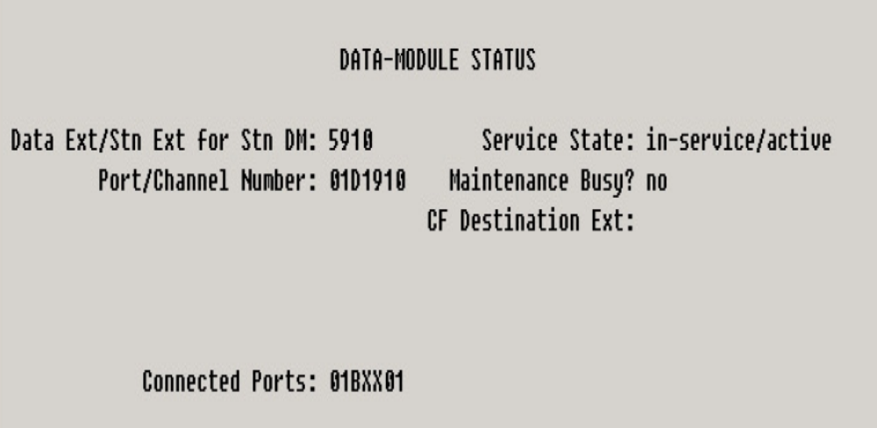

Avaya Sample NMI Messages

The following screens are sample NMI interface messages you will see when you update the phone status and the data is passed from the Avaya PBX switch to Meditech:

1) Example of Interface Message from NMI into MEDITECH using In Progress Code on the Phone Switch:

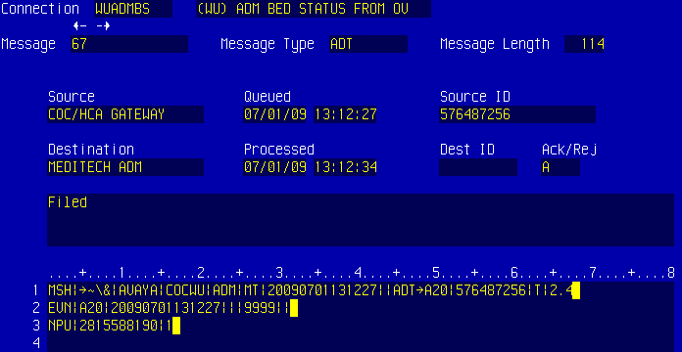
1 MSH|^~\&|AVAYA|COCWU|ADM|MT|20090701130356||ADT^A20|1087340454|T|2.4
Line 1: Is the type of Interface(AVAYA), Facility(COCWU), Date/Time

2 EVN|A20|20090701130356|||9999||
Line 2: Date/Time and the Housekeeper ID (9999)

3 NPU|2815585968|1
Line 3: Housekeeping Room Extension (2815585968) and Room Status Code (1 – In Progress(NMI))

2) Example of Interface Message from NMI into MEDITECH using Clean Code on the Phone Switch:

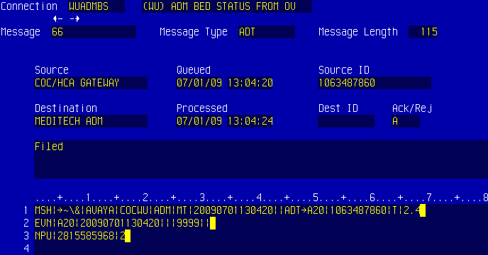
1 MSH|^~\&|AVAYA|COCWU|ADM|MT|20090701130356||ADT^A20|1087340454|T|2.4
Line 1: Is the type of Interface(AVAYA), Facility(COCWU), Date/Time
2 EVN|A20|20090701130356|||9999||
Line 2: Date/Time and the Housekeeper ID (9999)

3 NPU|2815585968|1
Line 3: Housekeeping Room Extension (2815585968) and Room Status Code (2 – Clean (NMI))

3) Example of Rejection of Data from Phone Switch thru NMI to MEDITECH:

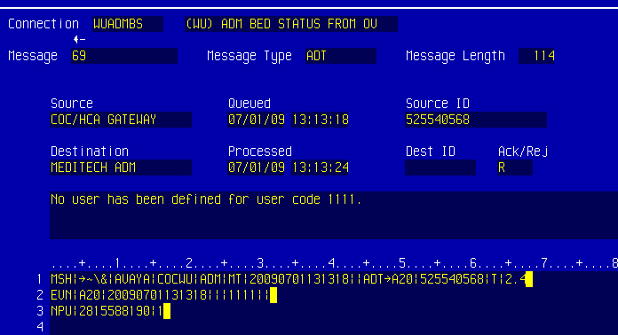
No user has been defined for user code 1111.
This error means that no Housekeeper has been setup with this code on Page 3 of the ADM Customer Defined Parameters.

4) Example of Rejection of Data from Phone Switch thru NMI to MEDITECH:

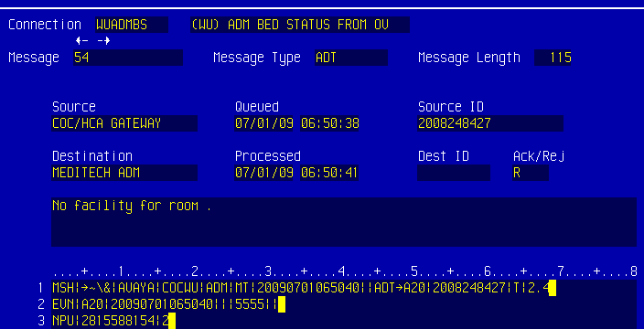
No facility for room .
This error means that the Housekeeping Extension (2815588154) is not setup in the room dictionary.

Trouble Shooting Avaya Room Status Messages

Note regarding error messages resulting from Housekeeper data entry errors:
- The Housekeeper has to enter all 4 digits of their ID for the system to give the user a Confirmation Tone. If they fail to enter 4 digits, the system will not send anything to the NMI Interface.

Avaya Cloverleaf and Interface Considerations
- The Cloverleaf engine will accept the transmission from the Lantronix box and format in HL7 format in accordance with MEDITECH interface specification, Other Vendor Bed Status Update to MEDITECH Admissions.
MEDITECH Magic Transactions

- In order to properly read transmissions from the Lantronix Box, each transmission must begin with STX character and the transmission must end with ETX.

- The integration consultant assigned by HCA corporate will work with each site to finish the configuration and test the interface prior to moving it into production.

- Training should be provided to sites that do not already have a working knowledge of MEDITECH NMI and Cloverleaf. This is done remotely.

